**SPH3U 11.8 Resistors in Circuits**

1. **Series and parallel**

|  |  |
| --- | --- |
| Equivalent resistance: |  |

|  |  |
| --- | --- |
| Series: |  |
| equation |  |

Four resistors are connected in series in a circuit. The resistances are as follows: R1 = 41 Ω, R2 = 51.75 Ω, R3 = 11.1 Ω, R4 = 102.008 Ω. Calculate the equivalent resistance.

|  |  |
| --- | --- |
| Parallel: |  |
| equation |  |

Three resistors are connected in parallel in a circuit. The resistances are as follows: R1 = 15 Ω, R2 = 12 Ω, R3 = 10 Ω. Calculate the equivalent resistance.

1. 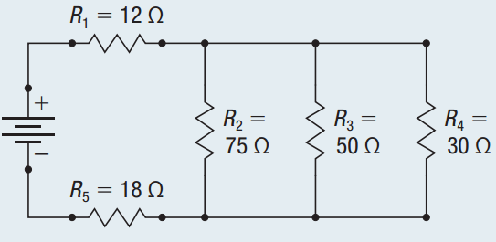**Mixed circuits**

Calculate the equivalent resistance for the circuit shown.

**Homework:** page 530: #4-5